HUB PRICING TOOL CALCULATION WORKFLOW



Document ID | DigDev_Hub_Pricing_Tool_Calculation_Workflow_v1.1
Product | HUB
Environment | ALL
Confidentiality Level | Internal / Restricted

Contents
1 DOCUMENT INFORMATION 4
1.1 Validation 4
1.2 Document Distribution 4
1.3 Version Control 4
2 PURPOSE & CONTEXT 5
2.1 About this document 5
2.2 Scope 5
2.3 Roles & Responsibilities 6
2.4 Terminology 6
2.5 Conventions Used 6
3 HAULER CATEGORIZATION OVERVIEW 7
3.1 Hauler Categorization Flow 7
3.2 Initial Pricing Tool Filters 9
3.3 QuickBase Eligibility Validation 9
3.4 Risk Flag Review 9
3.5 Categorization Outcomes 10
3.6 Relationship to Product-Specific Pricing Sections 10
4 Storage container pricing 11
4.1 Vendor Pricing Records 11
4.1.1 Vendor Pricing app in QuickBase 11
4.1.2 Hub app 11
4.2 MySQL Database 12
4.3 Hub App > Pricing Tool 13
4.4 Pricing Adjustments Process 14
4.5 Saving Records in QuickBase 15
4.5.1 Example 16
5 Portable toilet pricing 19
5.1 Vendor Pricing Records 19
5.1.1 Vendor Pricing app in QuickBase 19
5.1.2 Hub app 19
5.2 MySQL Database 20
5.3 Hub App > Pricing Tool 21
5.4 Pricing Adjustments Process 22
5.5 Saving Records in QuickBase 23
5.5.1 Example 25
6 ROLL-OFFS PRICING 28
6.1 Vendor Pricing Records 28
6.1.1 Vendor Pricing app in QuickBase 28
6.1.2 Hub app 28
6.2 MySQL Database 29
6.3 Hub App > Pricing Tool 30
6.4 Pricing Adjustments Process 31
6.5 Saving Records in QuickBase 32
6.5.1 Example 35
7 APPROVAL SIGNATURES 38

DOCUMENT INFORMATION

Validation
Name |  | Role | Date (dd/mm/aa)
Issued by | Oscar Rondon | Technical Writer | 30/06/2026
Verified by | Jose Carlos Osuna | Developer | 20/02/2026
Approved by | Anthony Bures | Digital Development Manager | 30/06/2026

Document Distribution
Normal | Role
Jose Carlos Osuna | Developer
Anthony Bures | Digital Development Manager

Version Control
Version | Date | Author | Description of changes
1.0 | 20/02/2026 | Oscar Rondon | 1st version of the Hub Pricing Calculation Tool
1.1 | 30/06/2026 | Oscar Rondon | Documentation Update related to section 3: “How the Pricing Tool Categorizes Haulers”

PURPOSE & CONTEXT

About this document
This document describes the technical pricing calculation flow used by the Hub application to generate customer pricing suggestions for:
- Storage Containers
- Portable Toilets
- Roll-Offs
It explains:
- Data synchronization from Vendor Pricing (QuickBase)
- MySQL storage structure
- Pricing adjustment logic
- Suggestion display rules
- Record creation in Sales Management QuickBase
The purpose is to provide engineering, QA, and product teams with a complete understanding of how pricing is calculated and persisted.

Scope
The scope of the pricing tool calculation includes the following.
In scope:
- Vendor Pricing → MySQL sync process
- Pricing Tool filtering logic
- Pricing adjustment algorithm
- Adjustment to hierarchy rules
- Field mappings between:
  - Vendor Pricing QuickBase
  - MySQL
  - Hub Pricing Tool
  - Sales Management QuickBase
- Record creation logic
- Rounding logic (when applicable)
- Experiment/Test flags
- Vendor list logic
Out of scope:
- Sales workflow usage instructions
- Pricing strategy decisions
- Manual overrides outside Hub

Roles & Responsibilities
Role | Responsibilities
Backend Developer | Implements and maintains pricing calculation logic, synchronization processes, and adjustment engine. Ensures pricing logic behaves as documented.
QA Engineer | Validates pricing calculations, adjustment behavior, rounding logic, and record creation. Confirms system behavior matches this SOP.
Vendor Management Team | Maintains Vendor Pricing records in QuickBase and ensures pricing data accuracy.
Digital Development Manager | Reviews and approves changes affecting pricing engine logic and production deployments.

Terminology
Term Used | Description
PSP | Preferred Service Provider (Vendor/Hauler)
Vendor Pricing | QuickBase app storing hauler rates
MySQL | Internal database storing synced pricing records
Pricing Tool | Hub feature that calculates pricing suggestions
Pricing Adjustment | Rule applied to increase/decrease customer price
DNU | Do Not Use flag
Zone RID | Pricing Zone Record ID
price_flag | Indicates fixed amount vs percentage adjustment
percentage | % used when price_flag = 0
amounts | Fixed value used when price_flag = 1
is_expire | Determines if adjustment expires
geography | Zip-based filtering logic
some PSPs | Adjustment applies only to specific IDs
Rounded | Indicates if final value is rounded before save

Conventions Used
The following structures are used as recommendations.
Info: Supplementary Information

Tip: A recommendation or useful advice

Warning: A warning or important notice

Note: A notice.

HAULER CATEGORIZATION OVERVIEW
The HUB Pricing Tool uses hauler pricing records, product-specific filters, QuickBase validation values, and risk indicators to determine how haulers are displayed in the Pricing Tool results. This categorization helps separate haulers into the following result groups:
Category | Description
Suggested Haulers | Haulers that meet the required Pricing Tool filters and do not have active risk indicators. These haulers are displayed as recommended options.
Other Haulers | Haulers that meet the minimum visibility requirements but have one or more risk indicators. These haulers are displayed as alternative options that may require review.
Not Eligible | Haulers that do not meet the required approval or visibility conditions. These haulers are not displayed in the Pricing Tool results.

The categorization process applies after the Pricing Tool receives or retrieves pricing and hauler-related data. The existing product-specific sections describe how records are synchronized from Vendor Pricing QuickBase into MySQL and then displayed in the HUB Pricing Tool using filters such as Zip Code, Address, Product Type, Size, Frequency, Debris, or other product-specific values.

Hauler Categorization Flow
The following diagram provides a high-level view of how the Pricing Tool categorizes haulers into Suggested Haulers, Other Haulers, or Not Eligible results.
The diagram summarizes the following process:
- Hauler pricing information is received or made available for the Pricing Tool.
- Pricing and hauler-related data is synchronized into the internal MySQL database.
- The Pricing Tool retrieves matching records from MySQL and applies initial filters.
- The system validates hauler eligibility using QuickBase values.
- If the hauler is eligible, the system checks quality and compliance risk indicators.
- Haulers with no active risk indicators are displayed as Suggested Haulers.
- Haulers with one or more active risk indicators are displayed as Other Haulers.
- Haulers that do not meet visibility or approval requirements are not displayed in the Pricing Tool.

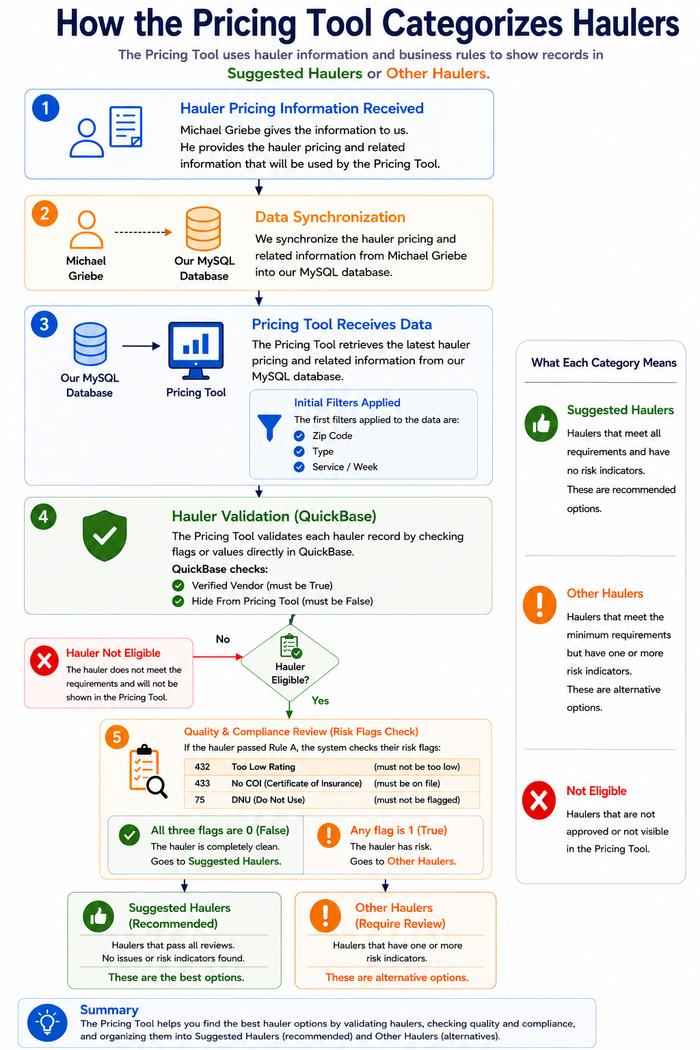

Initial Pricing Tool Filters
Before haulers are categorized, the Pricing Tool applies initial filters based on the product line and user-provided search criteria. These filters may include:
Filter Type | Description
Zip Code / Address | Used to find pricing records that match the service location.
Product Type or Size | Used to match the requested product or container size.
Frequency | Used when service frequency is part of the product pricing logic, such as Portable Toilets.
Debris Type | Used when debris type is part of the product pricing logic, such as Roll-Offs.
Product-specific criteria | Additional values that may apply depending on the selected Pricing Tool module.

The filters are not exactly the same for every product line. For example, the Roll-Offs Pricing Tool includes fields such as Size, Debris, Delivery, Charge, Days, Rental Rate, Tons, and Ton Rate, while the Portable Toilets Pricing Tool includes Frequency as part of the displayed pricing information.

QuickBase Eligibility Validation
After the initial Pricing Tool filters are applied, each hauler record is validated using QuickBase values. The validation determines whether the hauler can be displayed in the Pricing Tool. At a high level, a hauler must meet the required visibility and approval conditions before it can move forward in the categorization process. The diagram includes the following validation concepts:
Validation Check | Expected Result | Purpose
Verified Vendor | Must be True | Confirms that the hauler is approved for Pricing Tool visibility.
Hide from Pricing Tool | Must be False | Confirms that the hauler is not intentionally hidden from Pricing Tool results.

If a hauler does not pass the required eligibility checks, it is considered Not Eligible and is not displayed in the Pricing Tool.
Note: The exact QuickBase source fields for Verified Vendor and Hide from Pricing Tool should be confirmed with Development or Vendor Management before these values are used as formal QA validation fields.

Risk Flag Review
If the hauler passes the eligibility validation, the Pricing Tool then checks whether the hauler has active quality or compliance risk indicators.
The diagram identifies the following risk flag examples:

Risk Flag | Description | Expected Result for Suggested Haulers
Too Low Rating | Indicates that the hauler rating is below the acceptable threshold. | Must not be active
No COI | Indicates that the hauler does not have a Certificate of Insurance on file. | Must not be active
DNU | Indicates that the hauler is marked as Do Not Use. | Must not be active

If none of the risk flags are active, the hauler is categorized as a Suggested Hauler. If one or more risk flags are active, the hauler is categorized as an Other Hauler.
Note: The diagram references field identifiers for the risk flags. These identifiers should be confirmed against the correct QuickBase source table before being used for testing or troubleshooting.

Categorization Outcomes
After validation and risk flag review, the hauler is placed into one of three outcomes. This logic supports the Pricing Tool’s suggestion display rules by helping users identify the best available hauler options while still allowing lower-confidence alternatives to be reviewed when needed.
Outcome | Condition | Pricing Tool Behavior
Suggested Haulers | The hauler passes eligibility validation and has no active risk indicators. | The hauler is displayed as a recommended option.
Other Haulers | The hauler passes minimum eligibility validation but has one or more active risk indicators. | The hauler is displayed as an alternative option that may require review.
Not Eligible | The hauler does not pass the required visibility or approval conditions. | The hauler is not displayed in the Pricing Tool.

Relationship to Product-Specific Pricing Sections
This section provides the shared categorization logic used by the Pricing Tool. The following sections describe how this logic connects to each product-specific pricing workflow:
Outcome | Condition | Pricing Tool Behavior
Storage Containers | Section 4 | Explains the Storage Container pricing records, MySQL fields, HUB Pricing Tool columns, pricing adjustments, and QuickBase save behavior.
Portable Toilets | Section 5 | Explains the Portable Toilet pricing records, MySQL fields, HUB Pricing Tool columns, pricing adjustments, and QuickBase save behavior.
Roll-Offs | Section 6 | Explains the Roll-Off pricing records, MySQL fields, HUB Pricing Tool columns, pricing adjustments, and QuickBase save behavior.
Each product-specific section should be read together with this overview. The product sections explain how pricing values are retrieved, adjusted, and saved, while this section explains how haulers are categorized for display in the Pricing Tool results.

Storage container pricing
The following information describes how PSP pricing works for storage containers and explains the current pricing calculation.
1.
Vendor Pricing QuickBase
2.
Mysql Database
3.
Hub app: Pricing Tool
4.
Sales Management ZTER’s QuickBase

Vendor Pricing Records
Note: Records from the Vendor Pricing app in QuickBase are saved into the MySQL database.
There are two ways to keep the records updated:

Vendor Pricing app in QuickBase
When a new Container is added, or a record is edited or deleted, a webhook is triggered to update the corresponding record in the MySQL database.
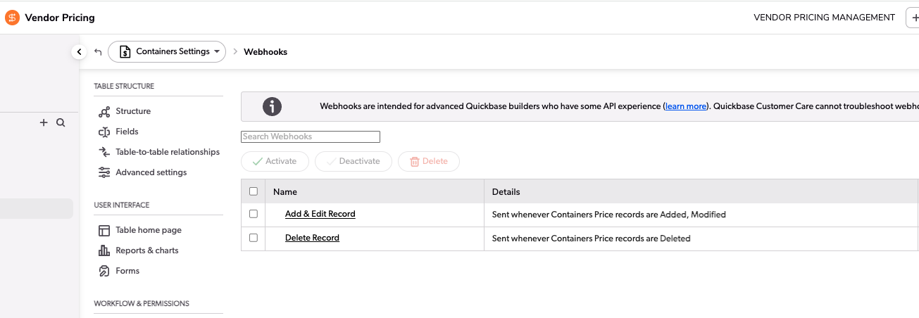

Hub app
The other way to sync all records is to click the 'Sync' button in Pricing > Settings in the Hub application. This option is only visible to users who belong to the “ZTERS.VendorManagement” group. This option syncs records for Toilets, Roll-offs, Containers, and Pricing Zones.
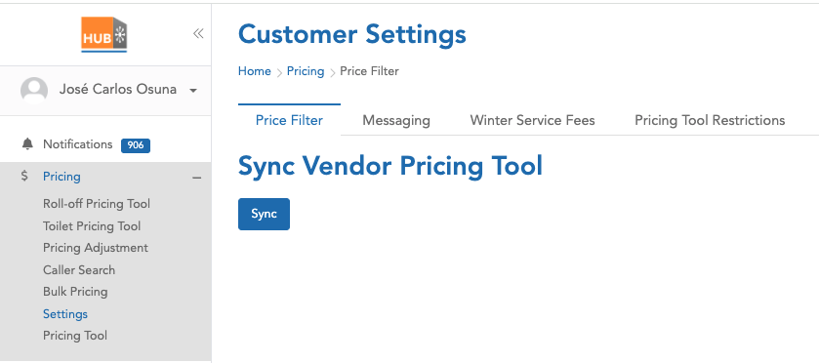

MySQL Database
The following are the fields saved in the MySQL database, along with their respective sources:
MySQL Field | Vendor Pricing QuickBase | FID
rid | Record ID# | 3
product_category | Product Type - Product Category | 11
product_type | Product Type | 13
pricing_zone_rid | Related Pricing Zone | 20
company_name | Company Name | 22
preferred_vendor | Preferred Vendor | 23
hauler_sales_rid | Hauler - Sales RID | 25
zone_type | Zone Type | 27
zip_list | Zip List | 33
zip_based | Pricing Zone - Zip List - Zip Based | 70
hauler_standard_charge | Standard Charge | 34
hauler_delivery_charge | Delivery Charge | 35
hauler_removal_charge | Removal Charge | 36
hauler_fuel_environ_percent | Fuel Environ % | 37
hauler_fuel_environ_dollars | Fuel Environ $ | 38
hauler_tax_percent | Tax % | 39
hauler_tax_dollars | Tax $ | 40
hauler_other_rate | Other Charge | 41
hauler_description | Other Description | 42
hauler_frequency | Other Billing Frequency | 43
hauler_dry_run_rate | Dry Run | 44
hauler_relocation_rate | Relocation | 45
address_miles | Pricing Zone - Address Miles | 59
depot_address | Pricing Zone - Depot Address | 60
depot_zip_code | Pricing Zone - Depot Address: Postal Code | 64
radius_miles | Pricing Zone - Radius Miles | 65
customer_standard_charge | Suggested Standard Charge 35% | 50
customer_delivery_charge | Suggested Delivery Charge 35% | 51
customer_removal_charge | Suggested Removal Charge 35% | 52
customer_total_charge | Suggested Total Charge | 58
pricing_zone_dnu | Pricing Zone - DNU | 76
dnu | DNU | 77
dnu_zone_or_individual | DNU - Zone or Individual | 78
added_rid | Internal | NA

Hub App > Pricing Tool
By applying filters such as Zip code and address, the Pricing tool in the Hub app shows records or suggestions based on the data stored in our database, originally imported from QuickBase. The following are the columns shown for Containers:
Column | MySQL Field
Provider Name | company_name
Category | product_category
Size | product_type
Rental / 28 days | customer_standard_charge
Delivery | customer_delivery_charge
Removal | customer_removal_charge

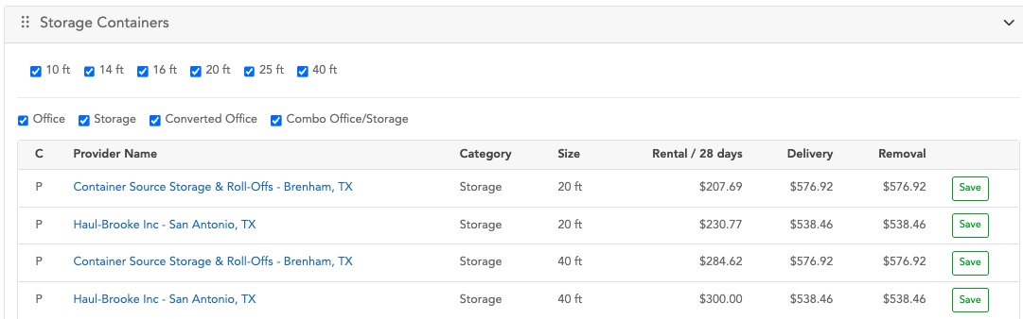
The value shown in the 'Rental / 28 days' column is, in some cases, different from the one saved in MySQL because a process applies certain pricing adjustments. These adjustments are designed to increase or decrease the final amount in that column and can be applied selectively to specific record IDs.

Pricing Adjustments Process
- Find a record in the pricingadjustment table, filtering by:
- Active
- Product: ‘all’ or ‘storage-container’
- is_applicable: ‘%Hub Pricing Tool%’
Tip: If there are no records in the previous table, no pricing adjustments are applied.

- The second step is to apply additional filters to the records retrieved from step 1:
- Check the expiration logic: if the 'is_expire' flag is set to '1' and the 'expire_date' is greater than or equal to the current date, or if the 'is_expire' flag is '0', the record continues processing.
- The second filter logic checks the value of the 'geography' column: records with the value 'all', or where the zip code is included in the list, are allowed to continue processing.

- The third step is to sort the records by priority and apply only the record with the highest priority.
Also, in a hierarchical manner, check whether it is necessary to apply the adjustment for specific PSPs:
- This applies if the record is of type 'some PSPs' or 'some confirmed prices', and the 'storage_container_id' column is not empty. If so, verify whether the suggestion record is included in the IDs stored in the 'storage_container_id' column.
- If the previous conditions are false, check whether the record type is 'all' or 'all PSPs', or if the product has a value of 'all'.

- The final record from the pricingadjustment table determines the amount to be increased or decreased. This adjustment can be applied to all records shown as suggestions, or to a specific record ID, depending on the value of the 'type' column (e.g., 'some PSPs' or 'some confirmed prices').
- If the ‘price_flag’ column has a value of “1”, the value in the ‘amounts’ column is directly considered as the amount to increase or decrease from the final total.
- If the ‘price_flag’ column has a value of “0”, the system takes the value from the ‘percentage’ column, divides it by 100, and multiplies the result by the original value from ‘customer_standard_charge’. This calculated value is then used to increase or decrease the final total.
- To determine whether the adjustment is an addition or a subtraction, the system uses the value in the ’price’ column, which indicates either increase or decrease.

Saving Records in QuickBase
Note: When the user clicks the Save button, a “Container” is created in the Sales Management ZTERs app in QuickBase.

The new container record is created based on the following information:
Sales Management ZTER’s QuickBase | FID | MySQL Field | Rounded?
Site ID | 58 | Parameters from the request
Category | 341 | product_category
Status | 22 | “Quote in Progress”
Product Type | 344 | According the size (10ft, 20 ft, 40ft)
Standard Charge (Customer) | 14 | customer_standard_charge | Yes
Delivery Charge (Customer) | 12 | customer_delivery_charge | Yes
Removal Charge (Customer) | 13 | customer_removal_charge | Yes
Pricing Tool Quote | 748 | 1
Pricing Tool Delivery Charge | 749 | customer_standard_charge | Yes
Pricing Tool Rental Charge | 750 | customer_delivery_charge | Yes
Pricing Tool Qty | 751 | 1
Pricing Tool Diagnostics | 753 | Parameters from the request
Hauler ID | 57 | hauler_sales_rid
Pricing Tool - Vendor List | 754 | hauler_sales_rid
Pricing Tool - Zone RID | 755 | pricing_zone_rid
Delivery Charge (Hauler) | 7 | hauler_delivery_charge
Removal Charge (Hauler) | 8 | hauler_removal_charge
Standard Charge (Hauler) | 9 | hauler_standard_charge
Fuel Environ Percent (Hauler) | 10 | hauler_fuel_environ_percent
Fuel Environ Dollars (Hauler) | 11 | hauler_fuel_environ_dollars
% Tax (Hauler) | 112 | hauler_tax_percent
Tax $ (Hauler) | 166 | hauler_tax_dollars
Other Charge (Hauler) | 110 | hauler_other_rate
Other Description (Hauler Rate) | 373 | hauler_description
Other Billing Frequency (Hauler Rate) | 374 | hauler_frequency
Dry Run (Hauler) | 378 | hauler_dry_run_rate
Relocation (Hauler) | 380 | hauler_relocation_rate

As part of the new record, a note is added with specific information such as Hauler ID, Hauler Name, Category, Type, Standard Charge, Delivery Charge, and Removal Charge. For these charges, both the original value and the rounded price are included.

Example
Hub app: Pricing Tool
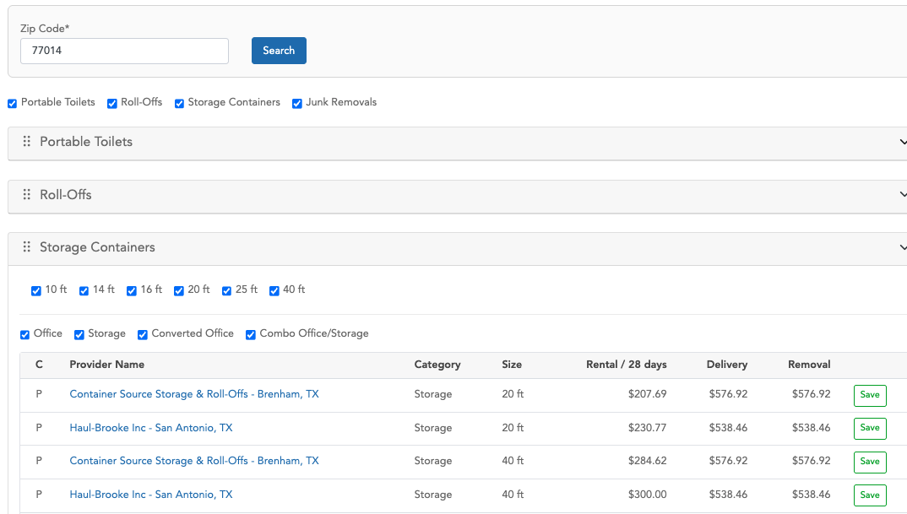
The following record was created using the first suggestion from the table, after clicking the Save button
https://zters.quickbase.com/nav/app/bhwfnx4uw/table/bhwgtqvvi/action/er?rid=53902
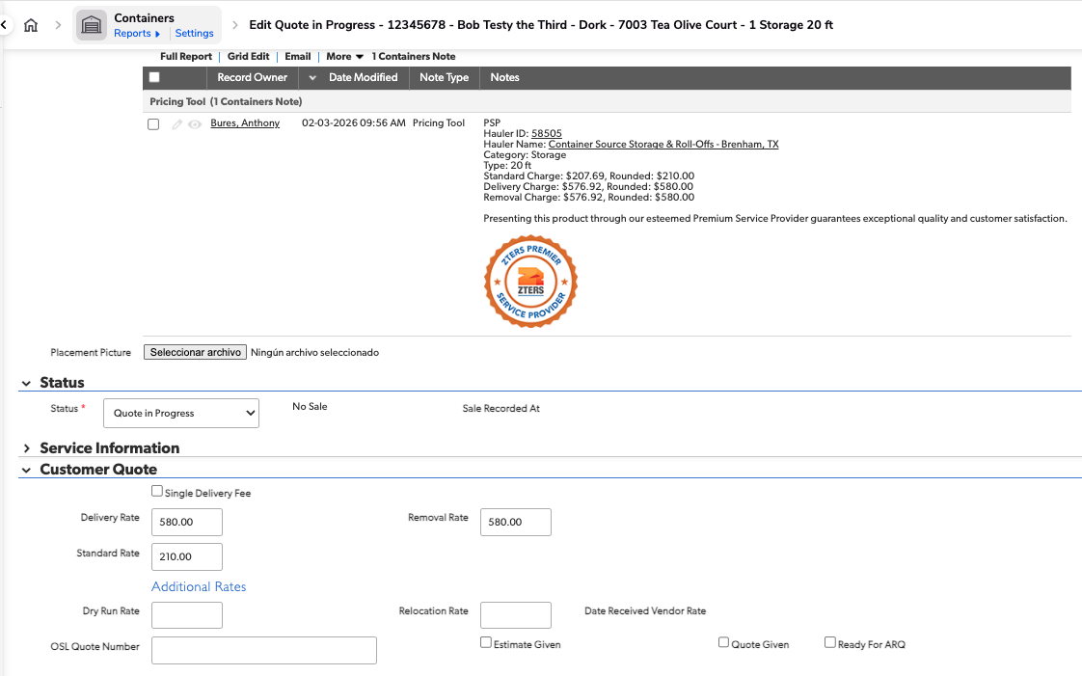
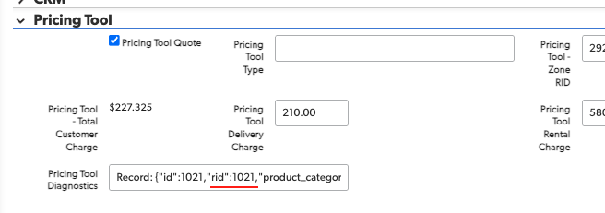
There is a Pricing Tool section in the Administrative tab. It displays the ID from the Vendor Pricing QuickBase, which, in this case, is record 1021.
https://zters.quickbase.com/nav/app/brd5gaz5n/table/breujuw2t/action/dr?rid=1021&rl=b8s

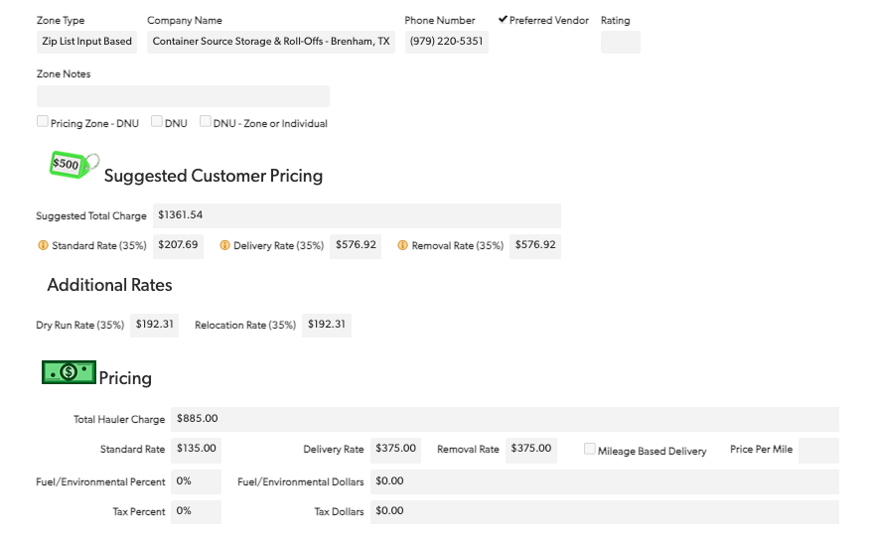
As you can see, the Standard Rate (35%), Delivery Rate (35%), and Removal Rate (35%) are the same as the values displayed in the Pricing Tool in the Hub app.

Portable toilet pricing
The following information describes how PSP pricing works for toilets and explains the current pricing calculation.
1.
Vendor Pricing QuickBase
2.
Mysql Database
3.
Hub app: Pricing Tool
4.
Sales Management ZTER’s QuickBase

Vendor Pricing Records
Note: Records from the Vendor Pricing app in QuickBase are saved into the MySQL database.
There are two ways to keep the records updated:

Vendor Pricing app in QuickBase
When a new toilet is added, or a record is edited or deleted, a webhook is triggered to update the corresponding record in the MySQL database.

Hub app
The other way to sync all records is to click the 'Sync' button in Pricing > Settings in the Hub application. This option is only visible to users who belong to the “ZTERS.VendorManagement” group. This option syncs records for Toilets, Roll-offs, Containers, and Pricing Zones.

MySQL Database
The following are the fields saved in the MySQL database, along with their respective sources:
MySQL Field | Vendor Pricing QuickBase | FID
rid | Record ID# | 3
3 | Record ID# | 3
11 | Product Type - Product Category | 11
13 | Product Type | 13
20 | Related Pricing Zone | 20
22 | Company Name | 22
23 | Preferred Vendor | 23
25 | Hauler - Sales RID | 25
27 | Zone Type | 27
33 | Zip List | 33
35 | Standard Charge | 35
36 | Delivery Charge | 36
57 | Pricing Zone - Address Miles | 57
58 | Pricing Zone - Depot Address | 58
62 | Pricing Zone - Depot Address: Postal Code | 62
63 | Pricing Zone - Radius Miles | 63
68 | Pricing Zone - Zip List - Zip Based | 68
71 | Standard Charge (Customer) | 71
72 | Delivery Charge (Customer) | 72
73 | Removal Charge (Customer) | 73
79 | Total Customer Charge | 79
93 | Service Frequency | 93
94 | Pricing Zone - DNU | 94
95 | DNU | 95
96 | DNU - Zone or Individual | 96

Hub App > Pricing Tool
By applying filters such as Zip code and address, the Pricing tool in the Hub app shows records or suggestions based on the data stored in our database, originally imported from QuickBase. The following are the columns shown for Portable Toilets:
Column | MySQL Field
Provider Name | 22
Product Name | 13
Frequency | Event: 11  Construction: 93
Standard | 71
Delivery | 72
Removal | 73

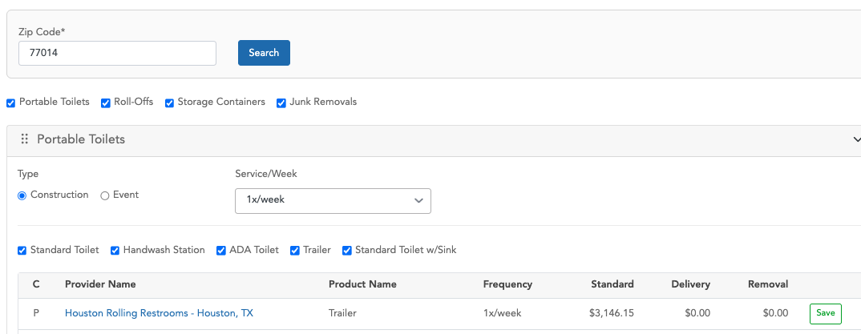
The value shown in the 'Standard' column is, in some cases, different from the one saved in MySQL because a process applies certain pricing adjustments. These adjustments are designed to increase or decrease the final amount in that column and can be applied selectively to specific record IDs.

Pricing Adjustments Process
- Find a record in the pricingadjustment table, filtering by:
- Active
- Product: ‘all’ or ‘toilet’
- is_applicable: ‘%Hub Pricing Tool%’
Tip: If there are no records in the previous table, no pricing adjustments are applied.

- The second step is to apply additional filters to the records retrieved from step 1:
- Check the expiration logic: if the 'is_expire' flag is set to '1' and the 'expire_date' is greater than or equal to the current date, or if the 'is_expire' flag is '0', the record continues processing.
- The second filter logic checks the value of the 'geography' column: records with the value 'all', or where the zip code is included in the list, are allowed to continue processing.

- The third step is to sort the records by priority and apply only the record with the highest priority.
Also, in a hierarchical manner, check whether it is necessary to apply the adjustment for specific PSPs:
- This applies if the record is of type 'some PSPs' or 'some confirmed prices', and the 'toilet_id' column is not empty. If so, verify whether the suggestion record is included in the IDs stored in the 'toilet_id' column.
- If the previous conditions are false, check whether the record type is 'all' or 'all PSPs', or if the product has a value of 'all'.

- The final record from the pricingadjustment table determines the amount to be increased or decreased. This adjustment can be applied to all records shown as suggestions, or to a specific record ID, depending on the value of the 'type' column (e.g., 'some PSPs' or 'some confirmed prices').
- If the ‘price_flag’ column has a value of “1”, the value in the ‘amounts’ column is directly considered as the amount to increase or decrease from the final total.
- If the ‘price_flag’ column has a value of “0”, the system takes the value from the ‘percentage’ column, divides it by 100, and multiplies the result by the original value from ‘customer_standard_charge’. This calculated value is then used to increase or decrease the final total.
- To determine whether the adjustment is an addition or a subtraction, the system uses the value in the ’price’ column, which indicates either increase or decrease.

Saving Records in QuickBase
Note: When the user clicks the Save button, a “Toilet” is created in the Sales Management ZTERs app in QuickBase.

As part of preparing the information needed to create the record, the system performs a query directly to the Toilets entity in the Vendor Pricing app in QuickBase, rather than retrieving the data from our local database. It then uses the retrieved information to attempt to create the new record.
The new toilet record is created based on the following information:
Sales Management ZTER’s QuickBase | FID | Vendor Pricing QuickBase FID | Rounded?
Status | 9 | ‘Quote in Progress’
Standard Charge (Customer) | 19 | 71 | Yes
Site ID | 25 | Parameters from the request
Pricing Tool Rental Charge | 539 | 71 | Yes
Delivery Charge (Customer) | 17 | 72 | Yes
Pricing Tool Delivery Charge | 540 | 72 | Yes
Per Unit Delivery (Zters) | 458 | 34
Per Unit Delivery (Vendor) | 333 | 34
Category | 576 | 11
Frequency of Service | 54 | Event: Event  Construction: 93
Portable Toilet Sales | 824 | true
Standard Charge (Hauler) | 13 | 35
Delivery Charge (Hauler) | 11 | 36
Removal Charge (Hauler) | 12 | 37
Fuel Environ Percent (Hauler) | 15 | 38
Fuel Environ Dollars (Hauler) | 16 | 39
% Tax (Hauler) | 86 | 40
Tax Dollars (Hauler) | 202 | 41
Containment Tray Rate | 621 | 42
Hand Sanitizer Rate | 622 | 43
Locking Hasp Rate | 623 | 44
Pump Rate | 624 | 45
Rigging Cage Rate | 625 | 46
Other Charge (Hauler) | 91 | 47
Other Description (Hauler Rate) | 605 | 48
Other Billing Frequency (Hauler Rate) | 606 | 49
Winterization Fee (Hauler) | 488 | 50
Dry Run (Hauler) | 610 | 51
Extra Service Charge (Hauler) | 14 | 52
Service Rate After Hours/Weekends (Hauler) | 627 | 53
Relocation (Hauler) | 612 | 54
Vendor Pricing RID | 853 | 3
Hauler ID | 30 | 25
Removal Charge (Customer) | 18 | 73 | Yes
Product Type | 581 | 14
Pricing Tool Quote | 538 | 23
Pricing Tool - Zone RID | 902 | 20
Pricing Tool - Experiment (Test) | 1127 | 138
Pricing Tool - Experiment (Control) | 1128 | 139
Pricing Tool - Vendor List | 901 | 25 (If FID 23 ==1)
Cycle Time | 118 | Construction: 28 Days  Event: Event

As part of the new record, a note is added with specific information such as Hauler ID, Hauler Name, Product Name, Frequency, Standard Charge, Delivery Charge and Removal Charge. For the charge-related fields, both the original value and the rounded price are included.

Example
Hub app: Pricing Tool
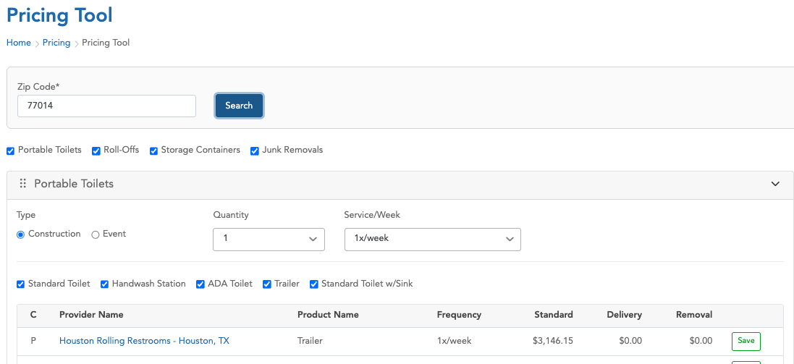

The following record was created using the first suggestion from the table, after clicking the Save button.
https://zters.quickbase.com/nav/app/bhwfnx4uw/table/bhwgum25y/action/dr?rid=1125608
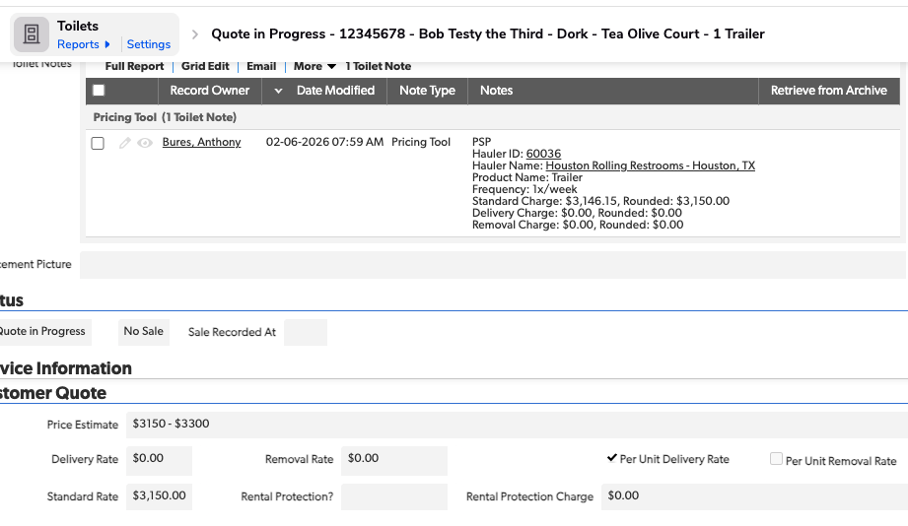
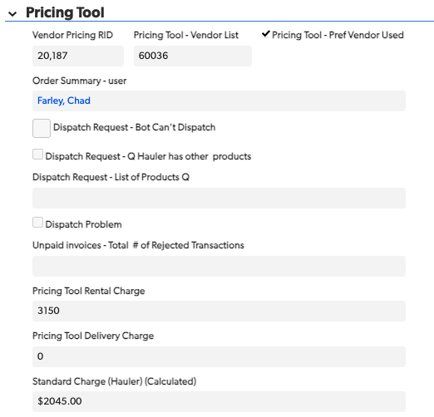
There is a Pricing Tool section in the Administrative tab. It displays the ID from the Vendor Pricing QuickBase, which, in this case, is record 20187.
https://zters.quickbase.com/nav/app/brd5gaz5n/table/breuj4sax/action/dr?rid=20187&rl=87

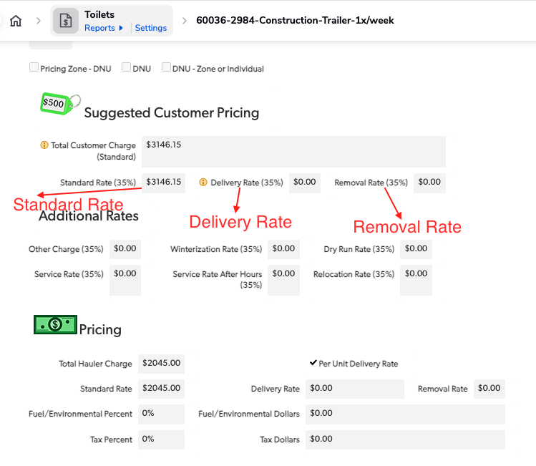
As you can see, the Standard Rate (35%), Delivery Rate (35%), and Removal Rate (35%) are the same as the values displayed in the Pricing Tool in the Hub app.

ROLL-OFFS PRICING
The following information describes how PSP pricing works for roll-offs and explains the current pricing calculation.
1.
Vendor Pricing QuickBase
2.
Mysql Database
3.
Hub app: Pricing Tool
4.
Sales Management ZTER’s QuickBase

Vendor Pricing Records
Note: Records from the Vendor Pricing app in QuickBase are saved into the MySQL database.
There are two ways to keep the records updated:

Vendor Pricing app in QuickBase
When a new Roll-off is added, or a record is edited or deleted, a webhook is triggered to update the corresponding record in the MySQL database.

Hub app
The other way to sync all records is to click the 'Sync' button in Pricing > Settings in the Hub application. This option is only visible to users who belong to the “ZTERS.VendorManagement” group. This option syncs records for Toilets, Roll-offs, Containers, and Pricing Zones.

MySQL Database
The following are the fields saved in the MySQL database, along with their respective sources:
MySQL Field | Vendor Pricing QuickBase | FID
rid | Record ID# | 3
3 | Record ID# | 3
13 | Product Type | 13
21 | Related Pricing Zone | 21
23 | Company Name | 23
24 | Preferred Vendor | 24
26 | Hauler - Sales RID | 26
28 | Zone Type | 28
34 | Zip List | 34
36 | Standard Charge | 36
37 | Delivery Charge | 37
39 | Rental Charge | 39
43 | Ton Rate | 43
59 | Standard Charge +$140 (Suggested) | 59
117 | Standard Charge +$140 (Suggested) for 3-15 | 117
60 | Suggested Delivery Charge 35% | 60
61 | Days Allowed (Suggested) | 61
62 | Suggested Rental Charge 35% | 62
63 | Delivery Rate Per | 63
65 | Tons Included (Suggested) | 65
115 | Tons Included (Suggested) for 3-15 | 115
66 | Suggested Ton Rate 35% | 66
118 | Suggested Ton Rate 35% #2 | 118
69 | Debris | 69
70 | Pricing Zone - Address Miles | 70
71 | Pricing Zone - Depot Address | 71
75 | Pricing Zone - Depot Address: Postal Code | 75
76 | Pricing Zone - Radius Miles | 76
81 | Pricing Zone - Zip List - Zip Based | 81
87 | Pricing Zone - DNU | 87
88 | DNU | 88
89 | DNU - Zone or Individual | 89
91 | Total Customer Charge +$140 (Suggested) | 91

Hub App > Pricing Tool
By applying filters such as Zip code and address, the Pricing tool in the Hub app shows records or suggestions based on the data stored in our database, originally imported from QuickBase. The following are the columns shown for Roll-Offs:
Column | MySQL Field
Provider Name | 23
Size | 13
Debris | 69
Delivery | 60
Charge | 117
Days | 61
Rental Rate | 62
Tons | 115
Ton Rate | 118

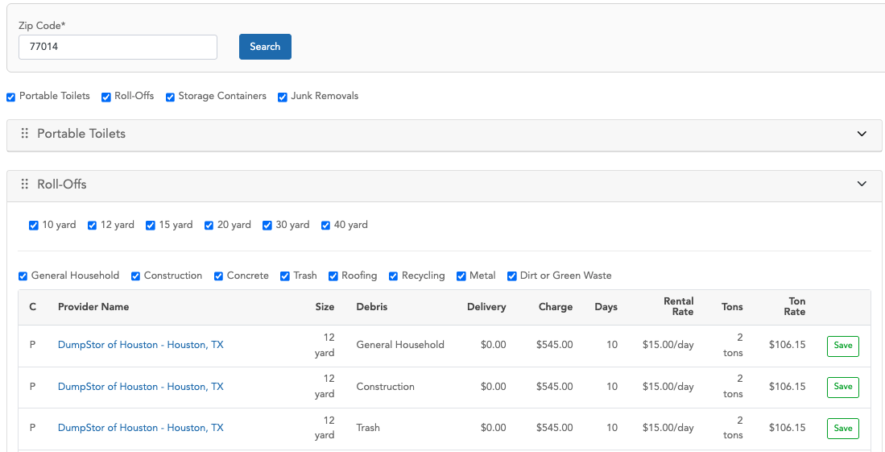
The value shown in the 'Charge' column is, in some cases, different from the one saved in MySQL because a process applies certain pricing adjustments. These adjustments are designed to increase or decrease the final amount in that column and can be applied selectively to specific record IDs.

Pricing Adjustments Process
- Find a record in the pricingadjustment table, filtering by:
- Active
- Product: ‘all’ or ‘dumpster’
- is_applicable: ‘%Hub Pricing Tool%’
Tip: If there are no records in the previous table, no pricing adjustments are applied.

- The second step is to apply additional filters to the records retrieved from step 1:
- Check the expiration logic: if the 'is_expire' flag is set to '1' and the 'expire_date' is greater than or equal to the current date, or if the 'is_expire' flag is '0', the record continues processing.
- The second filter logic checks the value of the 'geography' column: records with the value 'all', or where the zip code is included in the list, are allowed to continue processing.

- The third step is to sort the records by priority and apply only the record with the highest priority.
Also, in a hierarchical manner, check whether it is necessary to apply the adjustment for specific PSPs:
- This applies if the record is of type 'some PSPs' or 'some confirmed prices', and the 'dumpster_id' column is not empty. If so, verify whether the suggestion record is included in the IDs stored in the 'dumpster_id' column.
- If the previous conditions are false, check whether the record type is 'all' or 'all PSPs', or if the product has a value of 'all'.

- The final record from the pricingadjustment table determines the amount to be increased or decreased. This adjustment can be applied to all records shown as suggestions, or to a specific record ID, depending on the value of the 'type' column (e.g., 'some PSPs' or 'some confirmed prices').
- If the ‘price_flag’ column has a value of “1”, the value in the ‘amounts’ column is directly considered as the amount to increase or decrease from the final total.
- If the ‘price_flag’ column has a value of “0”, the system takes the value from the ‘percentage’ column, divides it by 100, and multiplies the result by the original value from ‘customer_standard_charge’. This calculated value is then used to increase or decrease the final total.
- To determine whether the adjustment is an addition or a subtraction, the system uses the value in the ’price’ column, which indicates either increase or decrease.

Saving Records in QuickBase
Note: When the user clicks the Save button, a “Dumpster” is created in the Sales Management ZTERs app in QuickBase.

As part of preparing the information needed to create the record, the system performs a query directly to the Rolloffs entity in the Vendor Pricing app in QuickBase, rather than retrieving the data from our local database. It then uses the retrieved information to attempt to create the new record.
The new roll-off record is created based on the following information:

Sales Management ZTER’s QuickBase | FID | Vendor Pricing QuickBase FID | Rounded?
Debris | 18 | 69
Size | 32 | 13
Quantity | 59 | 1
Status | 20 | “Quote in Progress’
Related Product Type | 441 | According to the size, the possible values for Product Type ID are:  10 yard => 73  12 yard => 74  15 yard => 75  18 yard => 76  20 yard => 77  25 yard => 78  30 yard => 79  35 yard => 80  default value 81
Product Type | 442 | It is the same case as in the row above
Site ID | 25 | Parameters from the request
PT Delivery Rate | 545 | 60 | Yes
Delivery Charge (Customer) | 14 | 60 | Yes
PT Rental Rate | 546 | 62 | Yes
Rental Charge (Customer) | 13 | 62 | Yes
PT Disposal Rate | 547 | 118 | Yes
Ton Rate (Customer) | 54 | 118 | Yes
Tons Included (Customer) | 33 | 115
Automatic Pull | 511 | 35
Standard Charge (Hauler) | 10 | 36
Delivery Charge (Hauler) | 9 | 37
Rental Charge (Hauler) | 8 | 39
Rental Type | 463 | 40
Rental Period Days | 464 | 55
Rental Rate Per Day | 776 | 56
Disposal Type (Hauler) | 453 | 41
Tons Included (Hauler) | 34 | 42
Ton Rate (Hauler) | 46 | 43
Standard Ton Rate Cutoff | 455 | 57
Conditional Ton Rate | 454 | 58
Fuel Environ Percent (Hauler) | 11 | 44
Fuel Environ Dollars (Hauler) | 12 | 45
% Tax (Hauler) | 97 | 46
Tax $ (Hauler) | 172 | 47
Other Charge (Hauler) | 95 | 48
Other Description (Hauler Rate) | 469 | 49
Other Billing Frequency (Hauler Rate) | 470 | 50
Dry Run (Hauler) | 472 | 51
Relocation (Hauler) | 474 | 52
Vendor Pricing RID | 742 | 3
Hauler ID | 35 | 26
Standard Charge (Customer) | 15 | 117 | Yes
PT Standard Rate | 544 | 117 | Yes
Days Allowed (Hauler) | 50 | 112
Pricing Tool | 542 | 24
Pricing Tool - Zone RID | 772 | 21
Pricing Tool - Experiment (Test) | 960 | 119
Pricing Tool - Experiment (Control) | 961 | 120
Pricing Tool - Vendor List | 771 | 26 (If FID 24 == 1)

As part of the new record, a note is added with specific information such as Hauler ID, Hauler Name, Size, Debris, Charge, Days Included, Rental Rate, Ton Rate, Tons, and Delivery Charge. For the charge-related fields, both the original value and the rounded price are included.

Example
Hub app: Pricing Tool
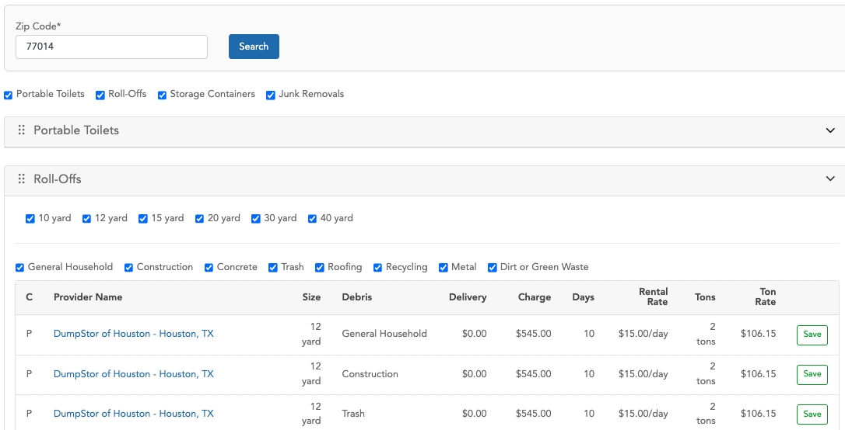
The following record was created using the first suggestion from the table, after clicking the Save button: https://zters.quickbase.com/nav/app/bhwfnx4uw/table/bhwgt8xdv/action/dr?rid=919241
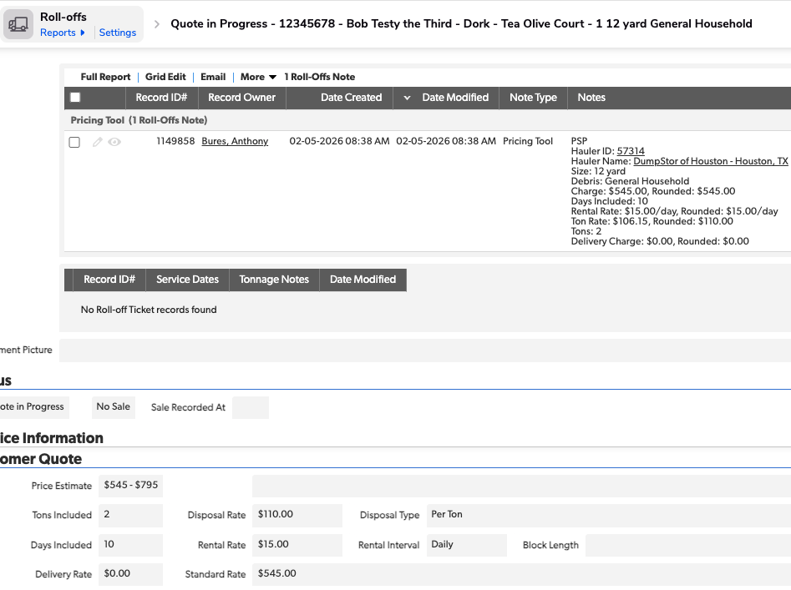
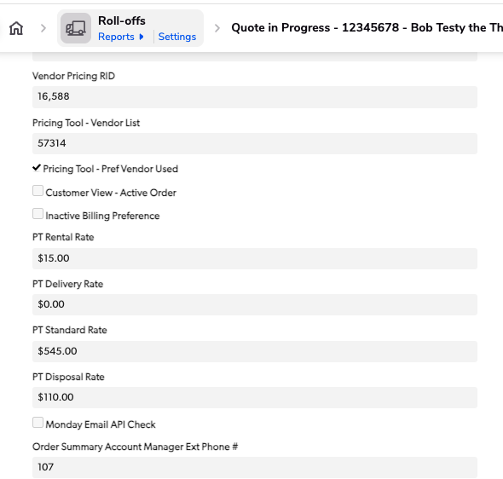
There is a Pricing Tool section in the Administrative tab. It displays the ID from the Vendor Pricing QuickBase, which, in this case, is record 16588.
https://zters.quickbase.com/nav/app/brd5gaz5n/table/breujw4za/action/dr?rid=16588&rl=vx3
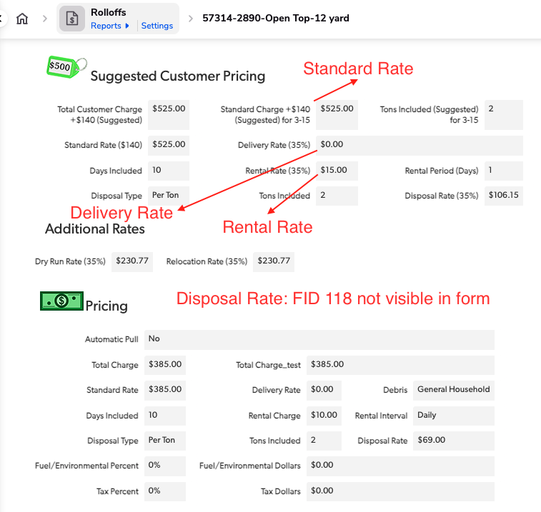
As you can see, the Standard Charge (+140, Suggested) for 3-15, the Delivery Rate (35%), Rental Rate (35%), and FID 118 (which is not visible in the form) are the same as the values displayed in the Pricing Tool in the Hub app—except for the Standard Charge. The values have a $20 increase due to the pricing adjustment process.

APPROVAL SIGNATURES
Digital signature blocks below are formatted for DocuSign / Adobe Sign.
Name | Role | Digital Signature Block | Date (dd/mm/aa)
Jose Carlos Osuna | Developer |  | 20/02/2026
Anthony Bures | Digital Development Manager |  | 20/02/2026

--- END OF THE DOCUMENT ---

